CS 505 Module Six Activity Tree Graphs

Complete this template by replacing the bracketed text with the relevant information.

Part One: Identifying Trees
For Part One, determine whether each graph provided is a tree.
- Explain whether each graph provided is a tree. If the provided graph is a tree, identify the root, leaves, and internal nodes. If the provided graph is not a tree, explain why.

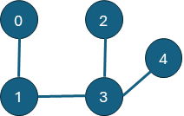
This graph is a tree, since every node is connected by only one path. All five nodes are connected and only four edges exist without cycles, satisfying the definition of a tree. The root is 3, since it has three branches and only one that is two edges away. Node 1 also has a maximum distance away of two edges, but only has two branches and two nodes are at maximum distance. The leaves are 0, 2, 4, while the internal nodes are 1 and 3. The root is an internal node because it has child nodes, and 1 has a child node, so is therefore also an internal node.
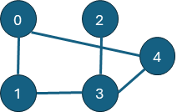
This graph is not a tree because it has a cycle. For example, we have an edge (0, 4) that could act as a path between 0 and 4. However, if we remove that edge, 0 still has a path to 4 via 1 and 3. Since removing an edge did not disconnect the graph, then the graph cannot be a tree.
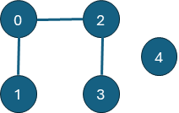
This graph is not a tree, but actually a forest. By definition, a tree of n vertices must have n - 1 edges to be connected, whereas this graph fails. It has five nodes, but only three edges, and therefore cannot be connected. However, 0, 1, 2, and 3 do make a tree on their own, while 4 is its own tree. This graph is a set of disjoint trees, making it a forest.

Part Two: Tree Properties
For Part Two, describe the key properties of trees, including edges, leaves, paths, and cycles.
- Prove that a tree with n vertices has n − 1 edges.
We prove by induction that every tree of n vertices has n - 1 edges.
In the base case, n = 1. We have one vertex. An edge can only exist between two vertices, and so with one vertex, there are no edges, so the rule is satisfied.
Let there be a tree of n vertices and assume it has n - 1 edges. Then, we add another vertex to the tree so that we have n + 1 vertices. In order for the graph to remain a tree, the new vertex must be connected to the rest of the tree, which means there exists an edge from the new vertex to another vertex in the tree such that we do not form a cycle. This adds a new edge, so we now have a total of n edges. Since this holds true for any n, then therefore a tree of n vertices must have n - 1 edges.
- Prove that a tree with n vertices has at least one leaf.
We prove by induction that every tree with n vertices has at least one leaf.
In the base case, n = 1. There is only one vertex. By definition, a leaf is a vertex with no children vertices. Since there is only one vertex in this case, it has no children vertices, and is therefore a leaf.
Let there be a tree of n vertices, one of which is a leaf. Then, we add a new vertex to the tree to make it have n + 1 vertices. To be connected, this vertex must share an edge with any other vertex. There are two cases: one in which the vertex is an internal node, so has two edges, or the other where it shares only one edge. In the first case, the leaf of the original tree remains a leaf, so there is still at least one leaf. In the second case, the new node itself is a child node of another. The new node does not have any children nodes of its own, and so therefore is a leaf itself, satisfying the rule. Therefore, for any tree of n nodes, it has at least one leaf.
- Explain why there is exactly one path between any two nodes in a tree.
Let’s assume by contradiction there exists no path between two nodes in the tree. Since the nodes do not have a path to each other, they are disconnected. However, by definition, a tree is connected, and therefore the nodes cannot be disconnected, which is a contradiction. Therefore, at least one path must exist between any two nodes in a tree.
In the other contradiction case, we assume there exists more than one path between two nodes in the tree. Removing any one edge will still allow the nodes to be connected because a path still exists. However, by definition, a tree is disconnected if any one edge is removed from the graph. Since by removing an edge, a path still exists, then the original graph would not be a tree. This is a contradiction, so therefore, only one path exists between any two nodes of a tree.
- Describe an algorithm to determine if a graph contains a cycle.
Let’s take a random graph of n vertices and m edges. We may try to form a tree out of the graph by checking the roots. We initialize a boolean such that there is no cycle and run a while loop on the boolean being false. We run a for loop through the list of edges to check if any roots are the same. If any edge between two nodes finds that the nodes share a root, that means a cycle exists and the loop breaks, returning the boolean as true. If we never find an edge that satisfies this condition, then we break the loop to return the boolean as false.

Part Three: Tree Traversal
For Part Three, explain tree traversals and basic tree operations.
- Explain pre-order traversal, including an example of a pre-order traversal of a binary tree.
Let’s consider the tree below. In pre-order, we start with the root, 1. We go to the first child, 2, followed by its children in order: 4 then 5. That is all the children of 2, so we move to the next child of 1, which is 3. Then we consider its child, 6. For a full binary tree, let’s still take the tree below but instead, remove 6 or add a child 7 to 3. The traversal is 1, 2, 4, 5, 3 in the first case, as 2 is the first child of 1, then we go through 2’s children, then go back to 1’s other child, 3. In the second case, after 6, we check child 7, finishing the traversal. The previous steps remain the same. Pre-order traversal goes through every child in order, and checks every generation via depth-first order. In other words, an entire branch is visited first, before going back to visit other branches. So for example, if 4 and 5 had children nodes, they would be visited first. 4’s children would be visited, then 5, then 5’s children, then back up the tree to go down 3’s branch.
- Explain in-order traversal, including an example of an in-order traversal of a binary tree.
For in-order traversal, we start with 4 in the tree below. This is the leftmost leaf in the entire tree. We then go to its parent node, 2, then traverse the next child of 2, which is 5. We move rightward along the tree, but go up to parent nodes first if necessary, then through the branches. So if 4 had children nodes 7 and 8, we’d start at 7, go to 4, then to 8, then back up to 2, then 5, and so on. For a full binary tree, we have nine nodes (where 8 and 9 are 4’s children). We start with 8, to its parent 4, then back down to 9. Then we visit 2, then 5, then 1. The closest node to 1 by left-right order is 3, because 6 is 3’s rightmost child, and is therefore to the ‘right’ of 3. However, if 6 was to the ‘left’ of 3, then it would be visited before 3. Generally, in-order traversal is a left-to-right depth-first search by going up the branches.
- Explain post-order traversal, including an example of a post-order traversal of a binary tree.
In post-order traversal, we start at the leaves, then go up the branches. In this traversal, the root is always last, as all its children must be visited first. Post-order visits children nodes first before visiting the parent node. In the tree below, we would start at 4 like in in-order traversal, but go to 5 next, as it is also 2’s child. After visiting 4 and 5, then we go to 2. Since 1 has another child in 3, we go to 3’s branch next, and visit its children, then itself, then finally 1. If 3 had no children, then we would visit it after 2. For a binary tree, we would have visited 3’s two children nodes, then 3, the finally 1. This is still a left-to-right order, but we finish an entire branch before going to the next.
- Perform a pre-order, in-order, and post-order traversal for the provided binary tree.
1
/ \
2 3
/ \ \
4 5 6
As explained earlier:
Pre-order: 1, 2, 4, 5, 3, 6
In-order: 4, 2, 5, 1, 3, 6
Post-order: 4, 5, 2, 6, 3, 1
- Find the height of the provided binary tree.
1
/ \
2 3
/ \ \
4 5 6
The height of this tree is 2. The root is 1 and the farthest leaves from 1 are all three leaves 4, 5, and 6. They are each two edges away from 1, so the height is 2.
- Find the number of leaf nodes of the provided binary tree.
1
/ \
2 3
/ \ \
4 5 6
As mentioned previously, the leaves are 4, 5, and 6, as none of them have children nodes of their own.
- Delete the node with value 5 from the provided binary tree.
1
/ \
2 3
/ \
4 6
Since 5 was a leaf, then the pointer is set to null.
- Insert a new node with value 7 as the right child of node 3 in the provided binary tree.
1
/ \
2 3
/ \ / \
4 5 6 7
We insert a new leaf 7 with 3 as the parent node. Since 3’s left child was null, we move 6 over into that spot so that 7 is the new right child node of 3.

Part Four: Tree Applications
For Part Four, explain file systems as trees, decision trees for classification, and the properties and implementation of binary search trees.
- Explain how a file system can be represented as a tree.
A file system can be represented as a tree because there is one root file, which stores the entire structure of the PC. Every file address must have C:\ at the beginning because the string represents the physical disk that stores everything. Under the C disk, there are multiple files, which are then child nodes of the root disk. Each of these files have children files, which may then also have children files. Folders are internal nodes, as they contain more files within themselves (unless it’s an empty folder, in which case it is a leaf). Individual files, such as txt, docx, png, and so on, are leaves. They do not contain more information that can be directly accessed within the file directory, so are represented as leaves.
For example, let’s consider my own D disk, so the file addresses will have a D:\ at the beginning. I can open the Steam folder, so Steam is a child node of the root D disk. The Steam folder contains the steamapps folder, so it is a child of the Steam folder, then we go to the common folder, which then has all the folders containing video games. So for example,
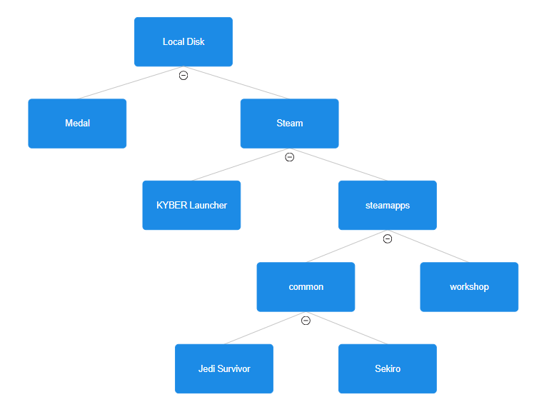
There are of course, many more files that exist in each folder, but we simplify here to show a binary tree instead of a general tree.
- Identify the root, internal nodes, and leaf nodes in a file system tree.
The root of a file system tree is simply the disk, as shown in the example provided above. The root contains everything and is also an internal node. The other internal nodes are the folders contained in the disk and these folders cannot be empty. In the binary tree example provided, Medal would not be an internal node, because it does not contain any files, so is a leaf node. On the other hand, Steam is an internal node because it has two child nodes. At the very bottom, Jedi and Sekiro are leaf nodes because they do not contain anything else. (Note this is the simplified version, so in my actual disk, they contain more files too and are therefore internal nodes in reality.) For a PC, the C:\ disk is the root node that contains everything, with folders such as Users, Program Files, and so on. Leaf nodes are all files such as text files, images, and documents, which do not have children nodes of their own.
- Describe how decision trees can be used to make decisions, including an example of a decision tree for a simple classification problem.
Decision trees are used, as by the name, to decide. Assuming a simple yes-or-no system, we can structure the decision tree as a binary tree. Each internal node is a question, while every leaf is a final decision. The root node, or root question could be something simple but important as ‘Do I do anything?’ which has a yes and no option. Yes would go to the next question while no would immediately go to a leaf of ‘Do nothing’ or something similar. Similarly, we can use a decision tree to classify things. For example, let’s say we are trying to classify a fish as an Atlantic cod. On the one hand, we could start with ‘Is it living?’ or ‘Is it an animal?’ if we’re going through a normal perspective. From a biological standpoint, we could ask ‘Is it single-cellular or multi-cellular?’ at the start, and then eventually ask what kingdom, phylum, class, and so on to determine an Atlantic cod.
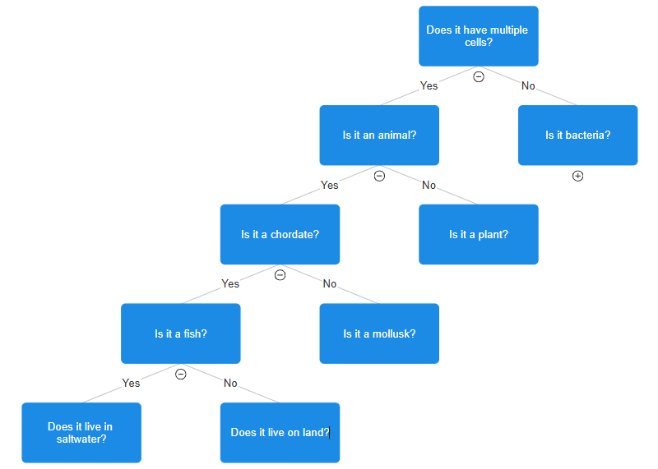
The decision tree may continue to determine the animal as an Atlantic cod. The other questions are other internal nodes that also have yes-or-no choices, appropriate for determining other living things.
- Explain the properties of a binary search tree.
A binary search tree is a binary tree that is sorted such that for every internal node, the value of its left child is always less than or equal to it, while the value of the right child will always be greater than it. It is not necessary that a node’s value is greater or less than a grandparent node’s value, only that it follows along with its parent node’s value appropriately.
- Implement a binary search tree using pseudocode.
function binary_search_tree(nodes) do
tree <- empty dictionary
root <- nodes[0]
tree[root] <- {left: null, right: null}
for node in nodes do
current_root <- root
new <- node
available_spot <- false
while available_spot is false do
if new <= current_root then
if tree[root][left] = null then
tree[root][left] <- new
tree[new] <- {left: null, right: null}
available_spot <- true
else do
current_root <- tree[current_root][left]
end if
else do
if tree[current_root][right] = null then
tree[root][right] <- new
tree[new] <- {left: null, right: null}
available_spot <- true
else do
current_root <- tree[current_root][left]
end if
end if
end while
end for
return tree

We set the initial value as the root of the tree and set it up as a dictionary such that the root has a left and right value. With every node, we check if its value is less than/equal to or greater than the current value, then change accordingly. If there already is a value, then we change the current value to the next one. We do this for every node and eventually return the tree.

